Quiz 2

Problem solving: Pseudo Code and flowcharts

- Write an Algorithm to Reverse a 3-digit number (Int). For Example, if 123 is given as input the output would be 321.
- What will be output of the following flowchart if number = 343 and num =343 is given as input. Complete the trace table given below for each iteration.
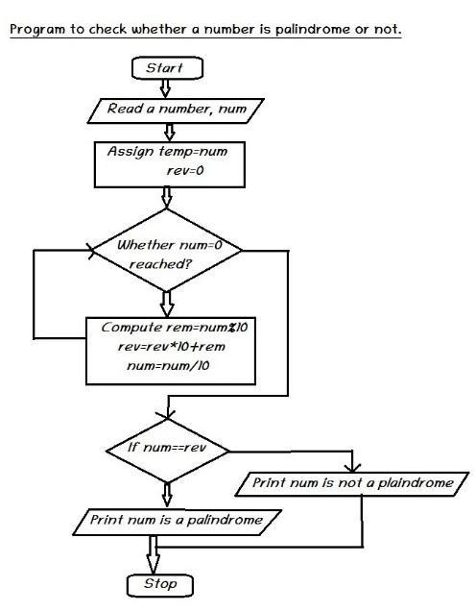
Temp is equal to rev?

Yes
NO
NO
Yes

number | num | temp | rev | rem

